Introduction

Save Your Listens (SYL) represents a music review web application that was created based on a project undertaken in the CMS 375 class at Rollins College during spring 2026. Users have the ability to keep a list of the songs they have listened to, rate the songs from 1 to 10, give reviews about the songs, and express their tastes for music among a group of other music enthusiasts. This project illustrates how a relational database can be embedded in an interactive web front-end.

A database was created by the name of music_reviews. Four tables were included in this database named Users, Reviews, UserReviews, and UserFavorites. Foreign keys have been implemented to establish the relationships between tables with a cascade delete rule. Passwords of the users were encrypted using password_hash() function in PHP, while inputs from the users were sa

The website contains the following six main views. The homepage displays current activity in the community. The songs finder makes it possible to search for songs directly within the browser. The song details page compiles reviews of one and the same song. The user profile page shows you your statistics and best song recommendations. The settings page contains all information related to your preferences as a user, while the community page shows site activity and popular posts. As an additional page provided by SYL, the friends page allows you to find more users to connect with.

The following pages provide detailed information about design choices, database architecture, development process, and difficulties faced when developing the SYL site.

ER Diagram
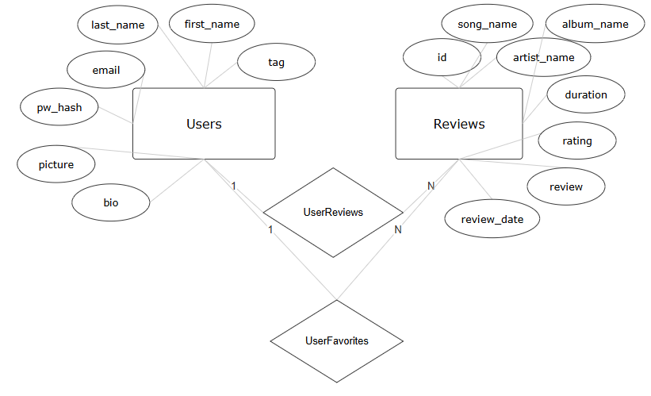

Database Design
The database has 4 entities as stated before: Users, Reviews, UserReviews, and UserFavorites. Users and Reviews are the two main entity tables that share relationship entities between given attributes. The other two relational tables, being UserReviews and UserFavorites, are the relationships that help connect the two main entity tables(User and Reviews).

Taking a deeper dive into the User table, we can look and see that the tag attribute is given as the primary key; it is the username, not a number. What the tag attributes do is store basic info such as the first name, last name, email, and bio. This helps with the profile and setting feature organization for the web application later during the development of the front-end UI design. The pw_hash attribute holds the user’s passwords. Passwords are never stored in plain text; using the hash function, we can encrypt sensitive information like a user’s password for best-fit protection. The picture attribute helps store an image file in the database for the given category it represents, in this case, that is the profile picture. Lastly, the email has to be unique; no two accounts can share the same email address.

The Reviews table has id as the table’s primary key; it is an auto-generated number. The overall Review table stores everything about the song and user review information, including: song name, artist, album, duration, ratingm the written review, and the date. There is no individual song table but the song is identified by name and artist. Duration is stored by seconds, the website converts it to minutes using a function in the code.

UserReviews is the bridge for Users and Reviews. The relationship between Users to Review is 1:N as one user can write a number of reviews. The combination of user and review is the primary key so there are no duplicates. This ultimately leads to if a user account is deleted there review and ratings are deleted as well.

UserFavorites gives users the feature to pin up to 4 favorite songs on their profile. The rank column (ranking 1 through 4) is part of the primary key. The design automatically limits to 4 favorite picks but give users the option to switch songs of their choosing. This relationship also cascades upon deletion as well like UserReview.

Overall the schema as a whole is pretty small but effective at covering everything that is involved in the application. All the data integrity rules are enforced in the database itself and not solely reliant on the code.

Implementation
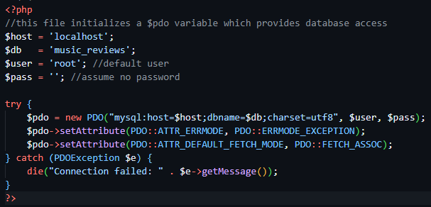
The backend of the application utilizes PHP 8.2 and connects to the database via the PHP’s PDO extension. The PDO object is constructed in the script where the connection is established, and this construction consists of a connection string which contains the host, the database name, the character set, and the required credentials to connect to the database. Two configuration parameters for the PDO connection exist here: the first one enables the ERRMODE_EXCEPTION option, thus SQL execution errors will result in exceptions; the second sets the FETCH_ASSOC mode.
User registration is done through a POST call where the entire process takes place in the server side and then passed into the database. This process involves sequential validations, where the checks are performed in a predefined sequence before moving to the next. First of all, the server will make sure that all three required fields, username, email address, and password are not left empty. The second step involves checking the validity of the username using a regular expression allowing alphabetic characters, numeric digits, and underscore symbols with a length from 2 to 32 characters. Password must be more than 8 characters, while its verification field should be matched.
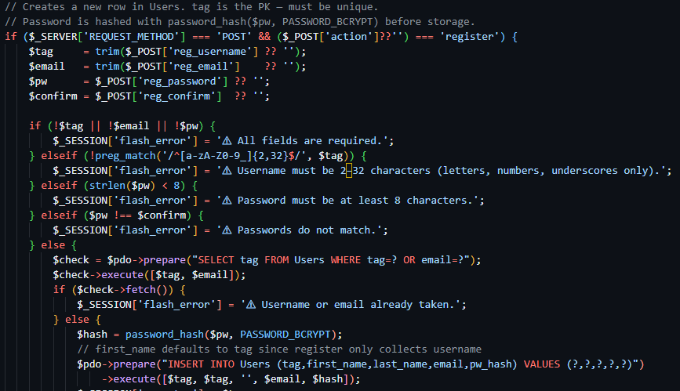
Once the input passes all the formatting tests, the server searches the Users table to see whether the username and email have been used before. To do this, the server runs a prepared statement that utilizes placeholders for the parameters, meaning that the user input is sent independent of the SQL statements. In this way, the risk of SQL injection attacks is completely avoided regardless of the user’s input.
Assuming all goes well, the password will be hashed using PHP’s password_hash() function with the PASSWORD_BCRYPT option prior to storage. BCrypt is a special-purpose hash algorithm that is intended to be slow and therefore difficult to brute force. The clear-text version of the password is immediately discarded and not stored at all in the database. A new user will be added with the INSERT query and with the first_name parameter set to the username, which is the only name field that is entered on registration.
The above mentioned technique is used everywhere within the application. The application does not use it only in one part; it uses it for user logging in, updating the profile, password change, and song upload.

Challenges
Within any ambitious project come its challenges; this project was no different. We stumbled upon a few challenges that held us back momentarily, but as a team, we dealt with the issues and provided solutions for most of the problems. One of the biggest issues we faced was connecting the front-end with the back-end and database. What made this harder was communication between the team, before we had a proper communication structure we would create large blocks or files of code and push into github. We hoped our files would be compatible with the code other team members pushed, but ultimately it would clash and lead to more debugging hours. Our solution was to create a thought out plan and diagram of who does what and exactly what part of the application they work on, essentially we broke down the project into smaller bits and divided the work. This helped out a lot because this method reduce less clutter, errors, and gave of more efficient time.

Another challenging segment in the project was designing the relationships between the tables. Befor we had a decent structure for the webpage we needed to see what entity connected to what and exalt how many of that entity can be used from the relation ship. This part of the project was more tedious and time consuming than it was technical. The solution for the design process was simply using a clear and normalized schema structure. We realized that the relationships would be a lot easier to set if we were to split tables into smaller branches and from there we go off the real world scenario we had planned when creating the idea.

The last challenge we had to overcome was later after most of the webpage was done, that was creating the sample data seed. In order for our team to properly test the webpage and the database we had to creat a 1 to 1 mock database seed to fill and test. This took time and lead us to majority of the errors we had post implementation phase. Creating the data alone for each mock users was time consuming, but work was split between team members for efficiency. After creating a sample database we had to remove any hardcode features that would be replaced by the mock users. This lead to certain bugs and compatibility errors since some code within the front-end was only coded for the hardcoded attributes. It took some time, but after reconstructuring some code and fixing it for user implementation we were left with a nice functional webpage.

Future Work
For future implementations, we would like to continue polishing the UI and adding more features to increase user engagement. There are some small fixes, such as buttons in the settings page that need to be polished and set better for the webpage aesthetic, and other small details of that nature. We decided that creating a reply system would allow users to interact better with one another and give more depth to our webpage. We would also like to implement playlists as a better way to show what the user likes from another user’s perspective. Some other future work we plan to include is to add more general customization options within the profile page. We also want to add more filter options in the community tab, as well as create more interactive features for users to stay engaged and up to date with our website’s general community. On the community page, a feature we want to polish is real-time analytics for community page feedback and posted reply times, which are set when a user posts a review. The time that is shown is not the real time that is shown on the review. Lastly, we would want to integrate song names via streaming sites to help autofill our database song catalog. This could potentially be done using an api that allows our site to communicate with the streaming platform to list the songs they have on their site. Of course, with the proper credentials and permission.

